PHYS.1410L (Physics I Lab)

UNIFORM CIRCULAR MOTION

INTRODUCTION

One specific type of circular motion is called ‘uniform circular motion’ (UCM) where an object moves in a circular path with constant speed. Maintaining this motion necessitates that a force with a specific magnitude acts continually on the object. In addition, the direction of the force must always be towards the center of the circular path. This force is referred to as the centripetal force. In this experiment you will investigate how the parameters involved in uniform circular motion are related to each other.

THEORETICAL BACKGROUND

For describing UCM it is helpful to introduce a coordinate system that is different from the typically used rectangular system. This system is referred to as the r, t, z coordinate system.

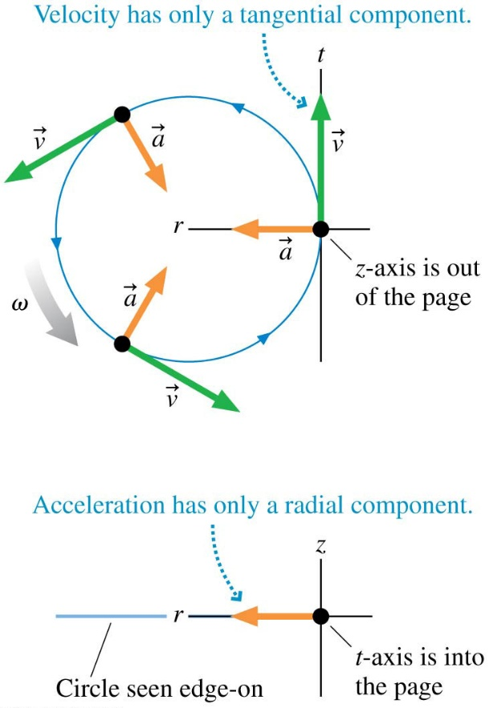

The motion of the object can be described by the following relationships:

$v_{r}$= 0 $a_{r}=\frac{v^{2}}{r}=ω^{2}$r $F_{r}=ma_{r}=mω^{2}r$

$v_{t}=ωr$ $a_{t}=0$ $F_{t}=0$

$v_{z}=0$ $a_{z}=0$ $F_{z}=0$

The above relationships indicate that the force causing the UCM is the radial component of the force on the object.

The tangential velocity ($v_{t}$) is constant for this motion, and therefore the angular velocity ($ω$) must also be constant.

The angular velocity can be written in terms of the period (T) of the motion: $ω=\frac{2π}{T}$

EXPERIMENTAL APPARATUS

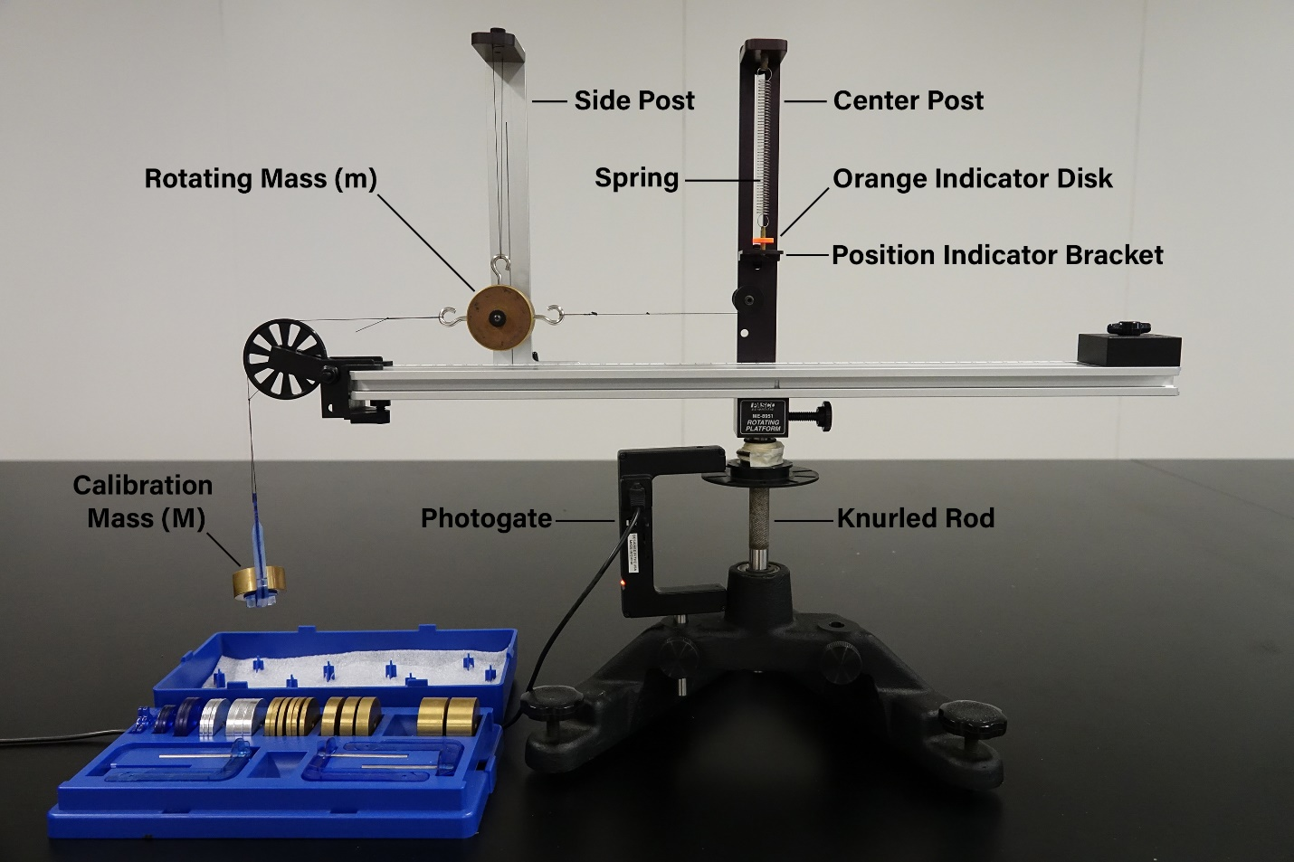

For the experimental apparatus used in this experiment, the centripetal force on the rotating mass will be supplied by the tension in the cord. This tension, in turn, will be due to the stretch of the vertical spring. Below are some definitions of parameters used in this experiment.
r = distance of the rotating mass from the center of the apparatus (i.e. radius of the motion)
m = rotating mass
M = calibration mass (includes the mass holder)
F_{r} = centripetal force (determined by a static measurement of Mg, gravitational force on the mass M) [when rotating – this is equal to the force of the spring on the rotating mass]

MEASUREMENTS

Go to the ‘Vernier’ folder. Open ‘Circular Motion’ folder.
Follow the instructions to test that the photogate is working.
Three different sets of measurements will be performed in which the period (T) will be measured. The results of the period measurement will enable the determination of the angular velocity ($ω$). In each of the data sets, two parameters will be held constant and a third varied. The Acquisition menu has three choices representing the parameters to be varied.
Data Set A: radius (r) and rotating mass (m) are held constant; centripetal force (F_{r}) is varied
Data Set B: radius (r) and centripetal force (F_{r}) are held constant; rotating mass (m) is varied
Data Set C: rotating mass (m) and centripetal force (F_{r}) are held constant; radius (r) is varied
Use an EXCEL spreadsheet to record all your measurements. Include the calculation of the angular velocity from the measured period.

For each measurement:
Choose and set the radius (r). Choose and set the mass of the rotating mass (m). Choose the calibration mass (M) which determines the centripetal force (F_{r}).
Make a static measurement of the spring force by connecting the calibration mass (M) to the rotating mass (m) with a cord. Adjust the location of the rotating mass so that it hangs vertically from the side post by positioning the top of the spring (use the set screw near the top of the center post). Next move the position indicator bracket so that it lines up with the orange indicator disk.
Remove the cord (along with the calibration mass) away from the rotating apparatus.
Set the apparatus in motion by using the knurled shaft to rotate the apparatus at a constant rate (i.e. constant angular velocity) such that the orange indicator disk stays aligned with the position indicator bracket. (This is accomplished by slightly adjusting the rate of rotation during the measurement.) Begin counting by clicking on START – it will automatically stop after 10 revolutions have been completed. Check the results of the run and if they are acceptable click ACCEPT the data.

For specific measurements:
Data Set A: (varying the centripetal force)
Set r to 0.15 meters and measure mass of bob (m) when it has two additional masses besides the center one. Measure the effect of varying the centripetal force by using 6 different values for the calibration mass (M). Begin with a 0.065 kg value and reduce its value in steps of 0.010 kg until you reach 0.015 kg.

Data Set B: (varying the rotating mass)
Set r to 0.15 meters and use a mass of 0.055 kg for the calibration mass M. Use the 5 possible masses (m) for the bob.

Data Set C: (varying the radius)
Use a mass of 0.055 kg for the calibration mass M. Use a rotating mass (m) when it has two additional masses besides the center one. Take measurements with 4 different values for the radius r using the range of 13 to 17 cm.

ANALYSIS
Data Set A: Plot a graph of the measured angular velocity versus the centripetal force. Analyze the results of the graph and compare your results to theoretical predictions.
Data Set B: Plot a graph of the measured angular velocity versus the rotating mass. Analyze the results of the graph and compare your results to theoretical predictions.
Data Set C: Plot a graph of the measured angular velocity the radius of the motion. Analyze the results of the graph and compare your results to theoretical predictions.

QUESTION
Consider a conical pendulum as shown in the diagram below. The motion of the conical pendulum is an example of uniform circular motion. If the bob is given only a tangential velocity it will swing in a horizonal plane and hence undergo UCM.
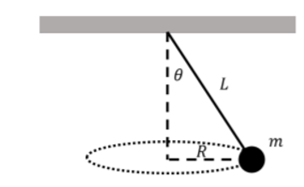

- Draw a labeled free-body diagram for the pendulum bob.
- Determine an expression for the tension in the cord. (using the parameters in the diagram)
- Determine an expression for the speed of the bob. (using the parameters in the diagram)
- Determine an expression for the period of the motion of the bob. (using the parameters in the diagram)
- Compare the period of a conical pendulum with that of a simple pendulum. Which one has a longer period?

